|  |  |
| --- | --- |
| Date | 31-10-2023 |
| Project Name | Public Transport Efficiency Analysis |

**DEVELOPMENT PHASE PART 2**

**PUBLIC TRANSPORT EFFICIENCY ANALYSIS**

**Table of Content:**

**\*Introduction**

**\*Data Cleaning and preprocessing**

**\*Visualization**

**\*Advanced data analysis**

**\*Visualization using IBM cognos**

**\*Conclusion**

**1.Introduction**

In the phase of this project, we continue our exploration of data analysis, diving deeper into the realm of public transport efficiency, In this phase, we shift our focus to public transport efficiency analysis, employing visualization techniques and predictive modeling to extract meaningful information and make data-driven decisions.

**2.Data Preprocessing**

Just as in the previous phase, data preprocessing remains a critical and essential step in our journey towards understanding and optimizing public transport efficiency. Data preprocessing can be described as "the collection and manipulation of data components to produce meaningful information." In this phase, we are dedicated to refining and enhancing the quality of our data, paving the way for more accurate predictions and insights

**3. Data cleaning and preprocessing:**

**import** pandas **as** pd

*# Load your dataset*

data = pd.read_csv(' Indrajithdataset.CSV')

*# Data cleaning and preprocessing steps (e.g., handling missing values, data type conversions, etc.)*

*# Example: Convert 'WeekBeginning' column to datetime*

data['WeekBeginning'] = pd.to_datetime(data['WeekBeginning'], format='%d-%m%Y %H:%M')

*# More data cleaning and preprocessing steps can be added here*

data.head(25)

TripID RouteID StopID StopName WeekBeginning No.Of.Boardings

|  |  |  |  |  |  |  |
| --- | --- | --- | --- | --- | --- | --- |
| **1** | 23631 | 100 | 14144 | 177 Cross Rd | 2013-06-30 | 1 |
| **2** | 23632 | 100 | 14132 | 175 Cross Rd | 2013-06-30 | 1 |
| **3** | 23633 | 100 | 12266 | Zone A Arndale Interchange | 2013-06-30 | 2 |
| **4** | 23633 | 100 | 14147 | 178 Cross Rd | 2013-06-30 | 1 |
| **5** | 23634 | 100 | 13907 | 9A Marion Rd | 2013-06-30 | 1 |
| **6** | 23634 | 100 | 14132 | 175 Cross Rd | 2013-06-30 | 1 |
| **7** | 23634 | 100 | 13335 | 9A Holbrooks Rd | 2013-06-30 | 1 |
| **8** | 23634 | 100 | 13875 | 9 Marion Rd | 2013-06-30 | 1 |
| **9** | 23634 | 100 | 13045 | 206 Holbrooks Rd | 2013-06-30 | 1 |
| **10** | 23635 | 100 | 13335 | 9A Holbrooks Rd | 2013-06-30 | 1 |
| **11** | 23635 | 100 | 13383 | 8A Marion Rd | 2013-06-30 | 1 |
| **12** | 23635 | 100 | 13586 | 8D Marion Rd | 2013-06-30 | 2 |
| **13** | 23635 | 100 | 12726 | 23 Findon Rd | 2013-06-30 | 1 |
| **14** | 23635 | 100 | 13813 | 8K Marion Rd | 2013-06-30 | 1 |
| **15** | 23635 | 100 | 14062 | 20 Cross Rd | 2013-06-30 | 1 |
| **16** | 23636 | 100 | 12780 | 22A Crittenden Rd | 2013-06-30 | 1 |
| **17** | 23636 | 100 | 13383 | 8A Marion Rd | 2013-06-30 | 1 |
| **18** | 23636 | 100 | 14154 | 180 Cross Rd | 2013-06-30 | 2 |
| **19** | 23636 | 100 | 13524 | 8C Marion Rd | 2013-06-30 | 3 |
| **20** | 23636 | 100 | 14122 | 173 Cross Rd | 2013-06-30 | 1 |
| **21** | 23636 | 100 | 13813 | 8K Marion Rd | 2013-06-30 | 1 |
| **22** | 23637 | 100 | 14156 | 181 Cross Rd | 2013-06-30 | 1 |
| **23** | 23637 | 100 | 14154 | 180 Cross Rd | 2013-06-30 | 1 |
| **24** | 23637 | 100 | 13335 | 9A Holbrooks Rd | 2013-06-30 | 3 |

*# Convert WeekBeginning to datetime and extract week number*

# **3.Visualization**

Line Chart - Weekly Boarding Trends

*# Convert WeekBeginning to datetime and extract week number* data['WeekBeginning']=pd.to_datetime(data['WeekBeginning']) data['WeekNumber'] = data['WeekBeginning'].dt. isocalendar().week

*# Group data by WeekNumber and sum the NumberOfBoardings* weekly_boardings = data.groupby('WeekNumber')['NumberOfBoardings'].sum()

*# Plotting*

plt.figure(figsize=(10, 6))

plt.plot(weekly_boardings.index, weekly_boardings.values, marker='o', color='green')

plt.title('Weekly Boarding Trends') plt.xlabel('Week Number') plt.ylabel('Total Number of Boardings') plt.grid(True) plt.tight_layout() plt.show()

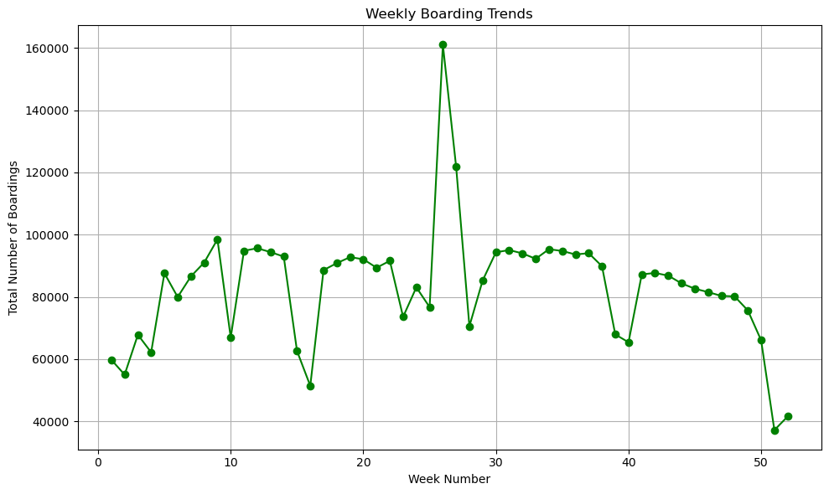

Bar Chart - Number of Boardings per StopName

**import** matplotlib.pyplot **as** plt

*# Group data by StopName and sum the NumberOfBoardings*

boarding_counts = data.groupby('StopName')['NumberOfBoardings'].sum()

*# Plotting*

plt.figure(figsize=(12, 6))

boarding_counts.sort_values(ascending=False).head(10).plot(kind='bar', color='skyblue')

plt.title('Top 10 Stops by Total Number of Boardings')

plt.xlabel('Stop Name')

plt.ylabel('Number of Boardings')

plt.xticks(rotation=45, ha='right')

plt.tight_layout()

plt.show()

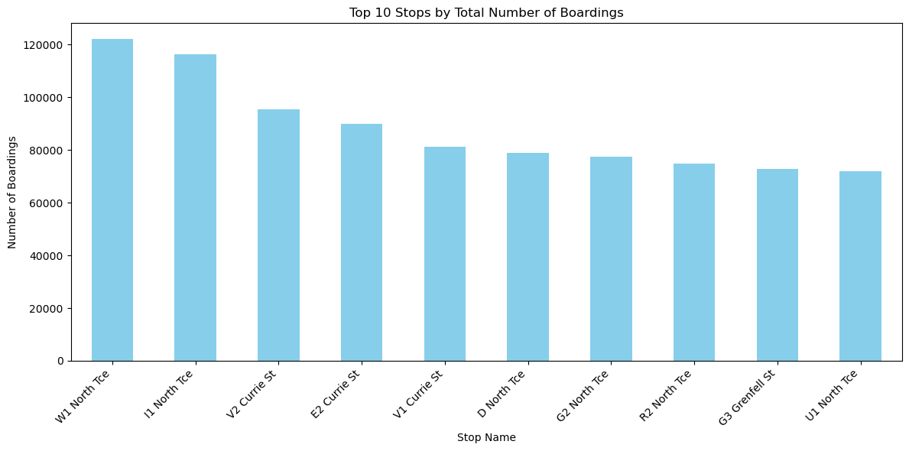

**3.1.Advanced data analysis**

Aggregating Boarding Counts by RouteID

**import** pandas **as** pd

*# Group by RouteID and sum the NumberOfBoardings*

boarding_by_route = data.groupby('RouteID')['NumberOfBoardings'].sum()

*# Display the result* print(boarding_by_route)

RouteID

117 312470

118 319790

140 83064

141 331118

142 79091

147 169540

148 5190

150 318672

168 296199

169 13397

170 143076

171 91911

100 328740

100B 8250

100C 11828

100K 6364

100N 6419

100P 13277

100S 260

101 39114

115 15460

117 67637

142 287270

144 183253

144G 15814

147 136496

150 105953

150B 55517

150P 8147

155 98191

157 307301

157X 81745

162 92171

167 237238

167C 32195

168 30858

Name: NumberOfBoardings, dtype: int64

*# Group by StopID and calculate the average number of boardings* avg_boardings_per_stop = data.groupby('StopID')['NumberOfBoardings'].mean()

*# Display the result*

print(avg_boardings_per_stop)

StopID

1. 2.776013
2. 2.333333

10843 2.257143

10877 2.326316

10879 1.400000 ...

1. 1.875000
2. 2.714286
3. 1.500000
4. 1.156250

18493 9.122678

Name: NumberOfBoardings, Length: 969, dtype: float64

Finding Stops with Highest Weekly Boarding Counts

*# Convert WeekBeginning to datetime and extract week number* data['WeekBeginning']=pd.to_datetime(data['WeekBeginning']) data['WeekNumber'] = data['WeekBeginning'].dt.isocalendar().week

*# Group by StopName and WeekNumber, then sum the NumberOfBoardings* weekly_boarding_counts = data.groupby(['StopName', 'WeekNumber'])['NumberOfBoardings'].sum()

*# Find stops with the highest weekly boarding counts*

stops_with_highest_boardings = weekly_boarding_counts.groupby('StopName').idxmax()

*# Display the result*

print(stops_with_highest_boardings)

StopName

1 Anzac Hwy (1 Anzac Hwy, 26)

1 Fullarton Rd (1 Fullarton Rd, 8)

1 George St (1 George St, 27)

1 Glen Osmond Rd (1 Glen Osmond Rd, 33)

1 Henley Beach Rd (1 Henley Beach Rd, 26) ...

Zone B Registry Rd Flinders Un (Zone B Registry Rd Flinders Un, 11)

Zone B West Lakes Interchange (Zone B West Lakes Interchange, 26)

Zone C Moseley St (Zone C Moseley St, 26)

Zone D Arndale Interchange (Zone D Arndale Interchange, 38)

Zone D Port Adelaide Interchan (Zone D Port Adelaide Interchan, 26)

Name: NumberOfBoardings, Length: 583, dtype: object

Analyzing Trends Over Time (Weekly/Monthly)

*# Convert WeekBeginning to datetime and extract week and month*

data['WeekBeginning'] = pd.to_datetime(data['WeekBeginning']) data['WeekNumber'] = data['WeekBeginning'].dt.week

data['Month'] = data['WeekBeginning'].dt.month

*# Group by WeekNumber and Month, then sum the NumberOfBoardings* weekly_boarding_trends = data.groupby(['WeekNumber', 'Month'])['NumberOfBoardings'].sum()

*# Display the result*

print(weekly_boarding_trends)

WeekNumber Month

1 1 59791

2 1 55026

3 1 67844

4 1 62204

5 2 87621

6 2 79964

7 2 86610

8 2 91046

9 3 98500

10 3 66953

11 3 94828

12 3 95643

13 3 94406

14 4 92959

15 4 62636

16 4 51434

17 4 88624

18 5 90852

19 5 92782

20 5 92112

21 5 89378

22 6 91608

23 6 73602

24 6 83086

25 6 76725

26 6 161049

27 7 121795

28 7 70588

29 7 85288

30 7 94344

31 8 95061

32 8 93992

33 8 92247

34 8 95341

35 9 94762

36 9 93643

37 9 94053

38 9 89866

39 9 67959

40 10 65428

41 10 87246

42 10 87703

43 10 86839

44 11 84346

45 11 82642

46 11 81556

47 11 80333

48 12 80176

49 12 75652

50 12 66079

51 12 37207

52 12 41587

Name: NumberOfBoardings, dtype: int64

**VISUALIZATION USING IBM COGNOS**

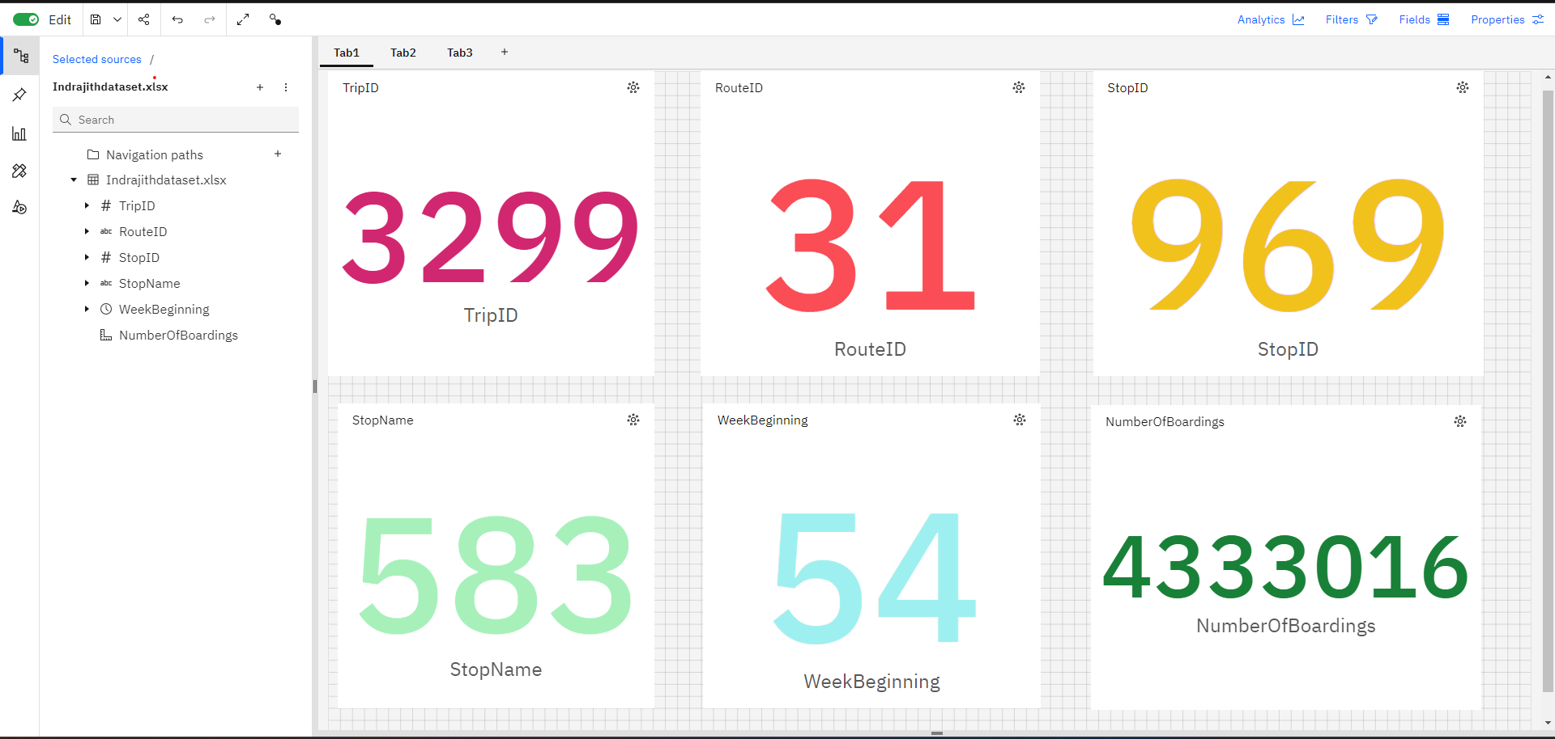

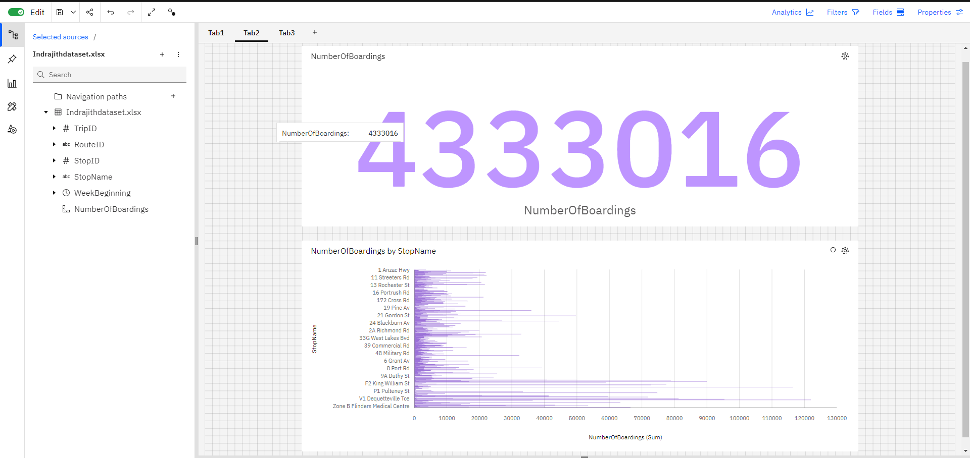

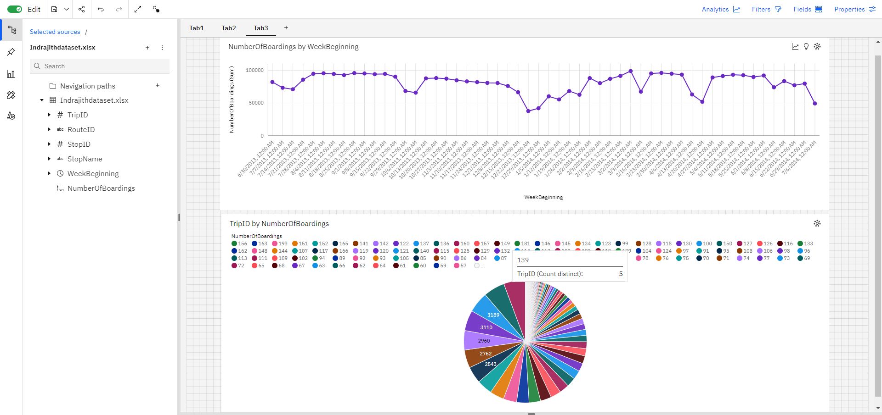

**4.Conclusion:**

In this project, we have continued our journey in the pursuit of comprehensive data analysis by creating visualizations and constructing a predictive model. Leveraging the capabilities of visualization libraries such as Matplotlib and Seaborn, we have unveiled insights through histograms, scatter plots, and correlation matrices. Additionally, we have delved into the realm of predictive modeling, where we have applied data-driven techniques to gain a better understanding of public transport efficiency Analysis.